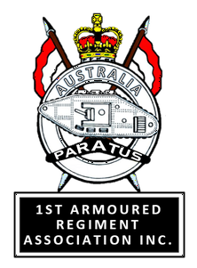

Reminder - Reminder - Reminder

Regimental Birthday Lunch - 8 July 2023

To join with us to Celebrate the 74th Regimental Birthday

Where/When: Broadford RSL from 1130 hours
Details: Broadford RSL. Sit down buffet lunch for $25 per head subsidised by $7 per head for Association members. Drinks at your own expense.
The lunch is open to all members and former members of the Regiment and an invitation is to be extended to all 1st Armoured Regiment personnel who may be in the area at that time.
Payment for the lunch will be required in advance (early-June) to ensure that the Association is able to advise our caterers of approximate numbers. Only 60 or so people will be able to attend – book now, or risk missing out!

As Iain Reynolds is currently in hospital, please advise secretary@paratus.org.au as soon as possible to ensure that we can get together! We need your name, the name of your guest (s), contact phone number and email address.

